# Project Report for CME 279

Axel Peytavin

## Modeling of the diffusion-reaction system in a synaptic cleft

### Introduction

The human brain works by transmitting signals between neurons, cells that constitute most of its matter. Electric signals are transmitted from neuron to neuron through complex patterns that ultimately create consciousness. To communicate these signals, neurons extend their axons towards another cell (not necessarily another neuron), and at the interface at the axon and the other cell, lies an interface called the synapse. The synaptic cleft is the thin region separating the axon of the neuron sending the signal, and the cell receiving the signal[1]. This interface is no wider than 20 to 30 nanometers. On the emitting, neurotransmitters (molecules) are released and let to diffuse towards the other end, where they connect to receptors, which fire the signal in the receiving cell. These neurotransmitters are also being transformed by enzymes in order to be evacuated and then reused later.

In this project, I modeled the diffusion of neurotransmitters from the moment they are released from their synaptic vesicle to the moment at which they reach the other side of the synaptic cleft. The specific neurotransmitter chosen is Glutamate, which represents up to 40% of the synaptic processes in the human brain[2].

### Modeling & Methodology

For this project, I used Cellblender with the MCell4 API for Python[3]. It allows to model the 3D evolution of diffusion-reaction systems and to visualize it inside a 3D modeling software called Blender. The setup is done through a Python file and the analysis of the results is done in a Python notebook. The visual screenshots are taken directly in Blender with the Cellblender plugin installed.

The model itself consists of a cylindric representation of the synaptic cleft with the approximate dimensions of a real one (see fig 1).

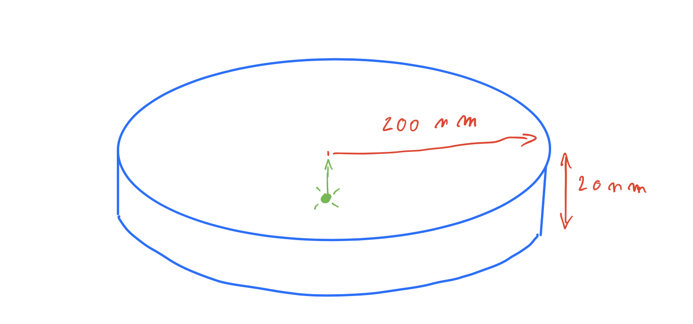

Figure 1: Schematic representation of our synaptic cleft. The particles are released at t=0 on the green dot and need to make their way to the top of the synaptic cleft

We release 5200 glutamate particles at t=0, which is believed to be a good estimation of how many molecules can be in a vesicle[4]. We set their diffusion coefficient to $2*{10}^{-6}$. Additionally, we add a reaction to allow for the particles to disappear, in order to model the actions of enzymes cleaning the cleft. In order not to have to model enzymes, we simply use the reaction $glutamate→ ∅$, which makes particles disappear randomly. We perform three experiments, one with no reaction and two with two different reaction forward rates. For each one of the experiments, we run the model for 1000 timesteps, each being 1 nanosecond, starting at the moment of release.

Our objective is to observe the rate at which particles reach the opposite point of the cleft and when the signal is the strongest. In order to determine that, we perform an experiment and then count the first time a particle reaches the opposite side of the cleft, if it does ever. A particle is considered as having reached the opposite end when it’s z coordinate is higher than 19 nm (the cylinder is 20nm high). We will then be able to observe the distribution of times of arrival for the whole set of molecules released.

### Results

#### First experiment: No reaction

We first run the experiment without any enzyme reaction. On Blender with the Cellblender plugin, we can observe the diffusion of the particles at different times (see fig 2).

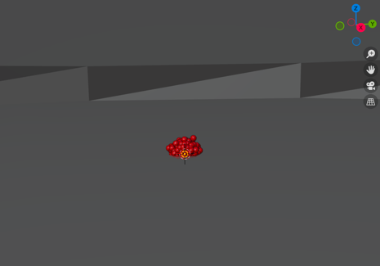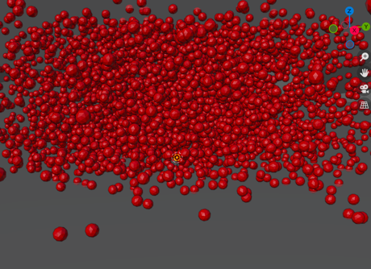

Figure 2: Representation of molecules in Blender w/ Cellblender at t=1ns, t=50ns, t=400ns

We observe that particles behave according to what was expected. In fig 3, we can see the evolution of the z-coordinate of one particle.

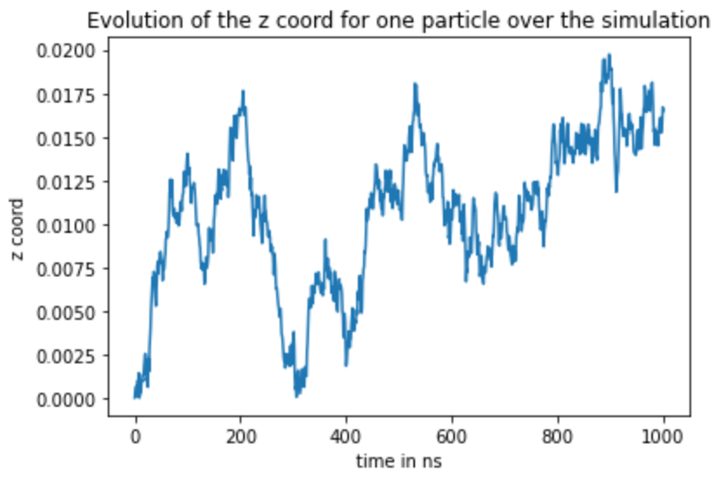

Figure 3: Evolution of the vertical coordinate for one particle over 1000 timesteps. After approximately 875 timesteps, it finally reaches the top of the cleft.

We then compute the distribution of times of arrival of the glumate molecules at the top of the cleft (see fig 4). The plots show that most of the particles have arrived after 2ms, and that the bulk arrives between 300 and 600ns.

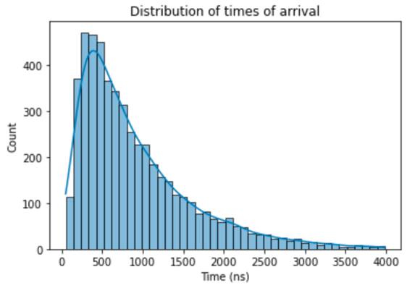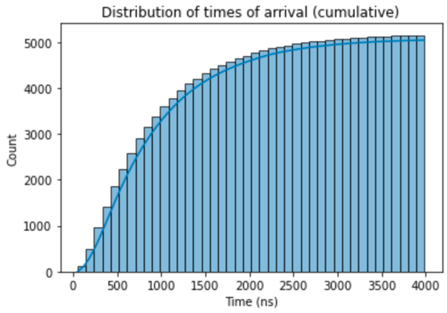

Figure 4: Distribution of times of arrival for the 5200 particles, with no reaction. On the left: Histogram, on the right: cumulative histogram

#### Other experiments: With enzyme reaction

We then run the experiment again with an additional reaction $glutamate→ ∅$, and observe how this changes the distribution of the arrival times. We distinguish two cases: the reduced consumption case with a forward reaction rate of ${10}^{6} s^{-1}$ and the increased consumption case, with a higher forward reaction rate of ${10}^{7} s^{-1}$.

As one could expect, adding this reaction reduces the number of glutamate molecules that make it to the other side of the cleft. From about 5000 in the previous experiment, it goes to 2500 in the reduced consumption case and just 120 in the increased consumption case. It also reduces the amount of time needed for the bulk of particles to reach the other side, with times of 200ns to 500ns in the reduced consumption case, to 100ns to 300ns in the increased consumption case.

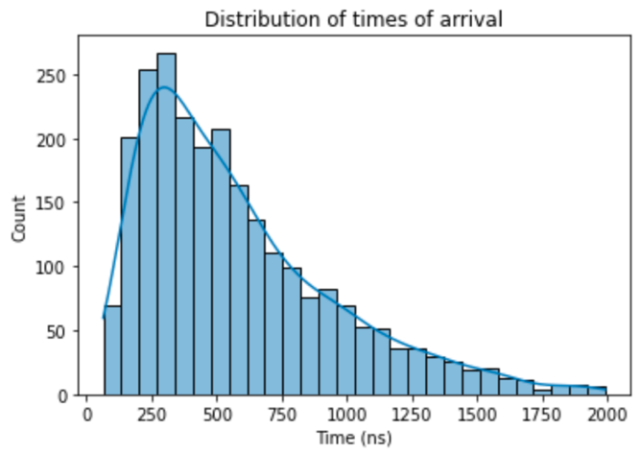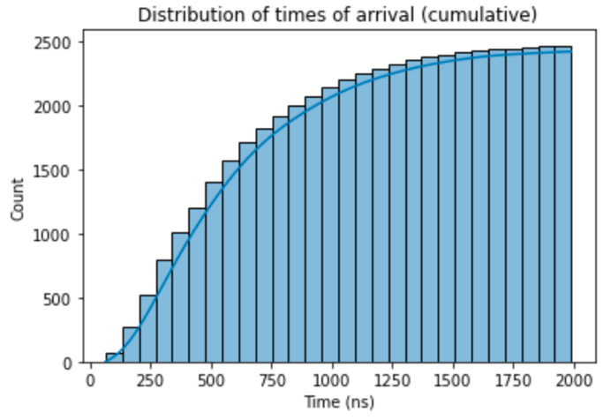

Figure 5: Histogram and Cumulative histogram of times of arrival for a forward rate of 10^6

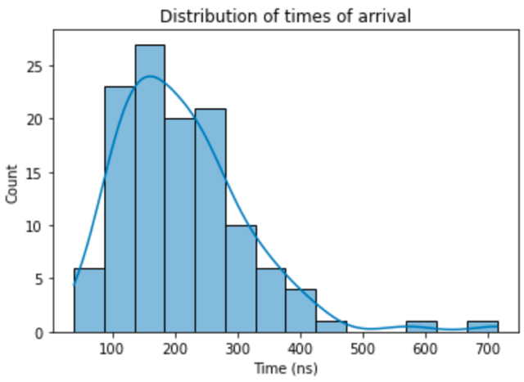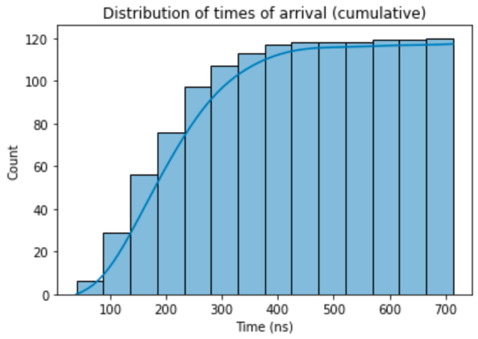

Figure 6: Histogram and Cumulative histogram of times of arrival for a forward rate of 10^7

### Discussion and future possible improvements

Our model may underestimate a bit the time needed for the signal to cross the synapse, as we modeled a cleft of 20nm width, whereas it can go up to 40nm, which would quadruple the time required to cross the cleft. However, our results, based on a very simple geometric model of a synaptic cleft, illustrate clearly the time scales of a signal transmission between neurons, aka that the signal needs at least about 0.5ms to go from one neuron to another[5]. It also shows how the presence of enzyme in the synaptic cleft, that are necessary to clean the place before the next signal can be sent, induces a reduction of time to pass signal but also a reduction of the number of neurotransmitters that cross the cleft. This shows that in real life there is a balance to be found between the power of the enzymes and the ability to successfully transfer the signal.

To further improve this model, there are many things that could be done, including:

* Modeling actual enzymes with another set of particles and thus modeling the real reaction between glutamate and, for example, glutamine synthetase[6].
* Modeling receptors[7] on the other end of the synaptic cleft, as the glutamate molecules do not only need to reach the other end of the cleft, they also need to find the receptor on the other wall. This should reduce the speed of transmitting the signal.
* Modeling different widths of the synaptic cleft.

### Code & Data - Reproducibility

The code and data used and generated for this project have been put in attached archive. In order to visualize the simulations produced, one would first need to install Cellblender, and then follow the instructions in the README file present a the root of the data.

1. Understanding the Role of Diffusion in Synaptic Transmission through Inquiry-Based Learning & Quantitative Reasoning

   Günther K. H. Zupanc

   The American Biology Teacher (2019) 81 (6): 435–441.

   https://doi-org.stanford.idm.oclc.org/10.1525/abt.2019.81.6.435
2. https://www-sciencedirect-com.stanford.idm.oclc.org/topics/medicine-and-dentistry/glutamatergic-synapse
3. https://mcell.org/
4. Counting the Number of Glutamate Molecules in Single Synaptic Vesicles

   Yuanmo Wang, Hoda Fathali, Devesh Mishra, Thomas Olsson, Jacqueline D. Keighron, Karolina P. Skibicka, and Ann-Sofie Cans

   Journal of the American Chemical Society 2019 141 (44), 17507-17511

   DOI: 10.1021/jacs.9b09414
5. https://theconversation.com/it-feels-instantaneous-but-how-long-does-it-really-take-to-think-a-thought-42392#:~:text=Instead%2C%20most%20signals%20are%20passed,passed%20within%20the%20single%20neuron.
6. Orr J, Haselkorn R. Kinetic and inhibition studies of glutamine synthetase from the cyanobacterium Anabaena 7120. J Biol Chem. 1981 Dec 25;256(24):13099-104. PMID: 6118371.
7. https://www-sciencedirect-com.stanford.idm.oclc.org/topics/neuroscience/glutamate-receptor